
RAMAIAH
Institute of Technology
USN | 1 | M | S

(Autonomous Institute, Affiliated to VTU)
(Approved by AICTE, New Delhi & Govt. of Karnataka) Accredited by NBA & NAAC with ‘A’ Grade

SEMESTER END EXAMINATIONS – JANUARY 2019

Course & Branch | : | B.E: Electrical and Electronics Engg. | Semester | : | V
Subject | : | Control Systems | Max. Marks | : | 100
Subject Code | : | EE52/EE502 | Duration | : | 3 Hrs

Instructions to the Candidates:
- Answer one full question from each unit.

 |  | UNIT- I
1. | a) | Explain the open loop and closed loop control systems with examples? | CO1 | (08)
 | b) | 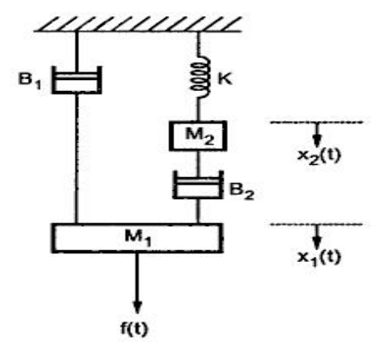  Obtain (i) F-V and (ii) F-I analogous circuit of the following mechanical system shown in Fig. 1(b)  Fig. 1(b) | CO1 | (12)
2. | a) | Explain the T-V & T-I analogy for Rotational systems. | CO1 | (08)
 | b) | Obtain the transfer function of the network shown in below Fig 2.(b)  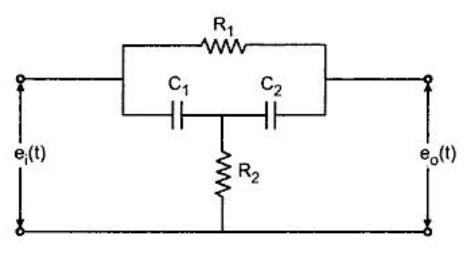  Fig .2(b) | CO1 | (12)
 |  | UNIT- II
3. | a) | With usual notations, derive an expression for steady state error of a unity negative feedback system. Hence derive expression for Positional and velocity error constant. | CO2 | (06)
 | b) | 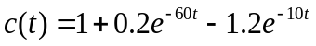 is the response of a system when subjected to a unit step input.  i) Obtain the expression for the closed loop transfer function.  ii) Determine the undamped natural frequency and damping ratio of the system. | CO2 | (06)
 | c) | The maximum overshoot and settling time for a control system whose overall transfer function is given by 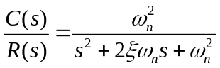 are 10% and 4 sec respectively. The input being a unit step input function. Determine the values of and 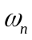 in order to satisfy these requirements. | CO2 | (08)
4. | a) | Derive an expression for time response 'c(t)' of a standard 2nd order system for i)under damped system, ii) Undamped and iii) Critically damped system. | CO2 | (12)
 | b) | For the following OLTF, given that the frequency of oscillation is 2 rad/sec and has poles at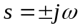. If no poles are in the right half of s plane find the values of K and a.,  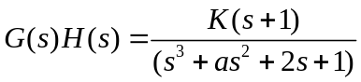 | CO2 | (08)
 |  | UNIT- III
5. | a) | A negative unity feedback system is having OLTF 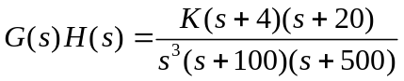. Find the range of K from RH criterion for which system stable. | CO3 | (12)
 | b) | With respect to location of characteristic roots on s-plane, define the following terms:  (i) absolute stability (ii) marginal stability  (iii) conditional stability (iv) critically stable system. | CO3 | (08)
6. | a) | Explain the procedure to plot root locus? Explain how to find angle of departure and angle of arrival for complex poles and zeros. | CO3 | (10)
 | b) | Sketch the root locus plot and find stability for a unity feedback system whose OLTF is given as 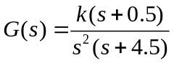 . Check whether system is conditionally stable?. | CO3 | (10)
 |  | UNIT- IV
7. | a) | Draw the polar plot of 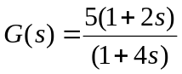 | CO4 | (06)
 | b) | Sketch the Nyquist plot and determine stability of the following open loop transfer function of unity feedback control system 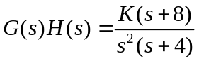 . Comment on its closed loop system stability. | CO4 | (14)
8. | a) | A unit step input is applied to unity negative feedback system having OLTF 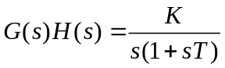. Determine K and T to have peak overshoot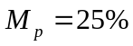 and resonant frequency 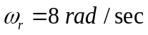. Also find resonant peak 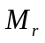 | CO4 | (10)
 | b) | Using Nyquist stability criterion, investigate the stability of closed loop system whose OLTF is 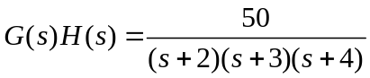. | CO4 | (10)
 |  | UNIT- V
9. | a) | Determine the values of gain k for the following open-loop TF so that gain margin is 15 Db and Phase margin is 60°.  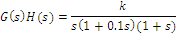 | CO5 | (12)
 | b) | Obtain the transfer function of RC lag compensator, for 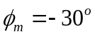and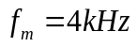. Assume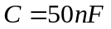. Also find the corner frequencies. Using vector diagram show that output waveform lags the input. | CO4 | (08)
10. | a) | Obtain the transfer function from the following bode diagram in Fig. 10(a).  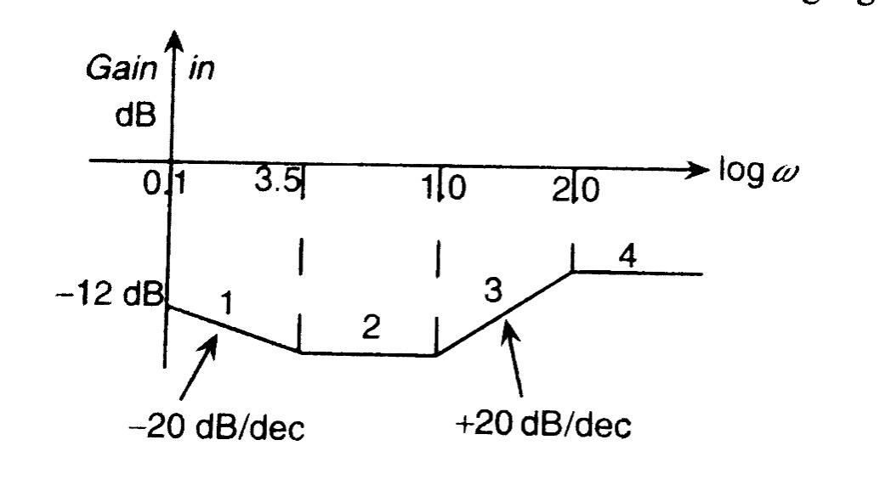  Fig 10(a) | CO1 | (12)
 | b) | Obtain the transfer function of RC lead compensator, for 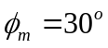and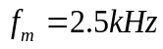. Assume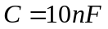. Also find the corner frequencies. Using vector diagram show that output waveform leads the input. | CO1 | (08)

****************

